Specialist Negotiated Project
Supporting Animal Welfare PETA UK
Manya Alkhmri
Final evaluation
In my project proposal, I have identified this module as an extension to my dissertation about the power of activist art. The main purpose of this project is to focus on highlighting animal welfare through supporting PETA (People for the Ethical Treatment of Animals). This project will be a focal point for an upcoming art project to be held in the Centre for International Women Artists in Manchester during the summer of 2021. It will also include an art exhibition and workshops to support animal welfare in conjunction with PETA.
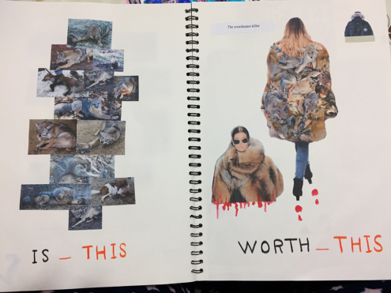
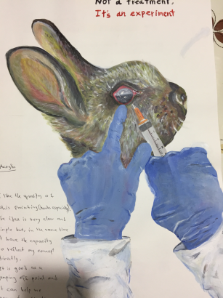
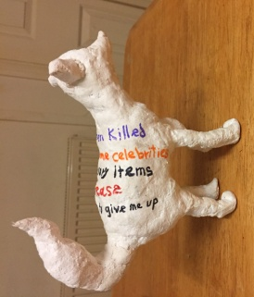
Following on from my project proposal and presentation, my focus turned to develop ideas and building supporting evidence to show the capability of controlling the creative process through planning, analysis, synthesis and continual evaluation that leads to meaningful and justifiable final outcomes. At this point, I had developed a set of ideas using various techniques and materials in an attempt to reach my goal of evoking thoughts and raising awareness about animal welfare. In my project proposal, I have concluded that the creativity of the idea is the centre of my subject. To achieve that, I set some rules for myself on how to express those ideas by implementing clear, compelling, and composed messages which highlight cruelty towards animals. I worked hard to develop some powerful sketches to achieve the required expectations in producing appropriate final pieces that exhibit maturity and a level of professionalism. I tended to use advertising art as I feel that nothing is more efficient to convey my message than a creative advertising style, it is more memorable and longer-lasting.

Selecting ​​artwork alongside descriptive sentences, I think I have successfully completed a set of works that meet my aspirations.
However, a lot of activist act traditionally evokes and portrays a more sinister and thought-provoking side laced with undertones of the political. I have tried to approach the seriousness and brutal imagery of animal abuse with limited shock appeal so as to draw in the audience to really see the beauty of these creatures and thus to then question the ill-treatment of animals. By freeing myself from the typical associations people might expect from seeing this type of art, I was able to stretch my ability as an artist working on a chosen subject.
Later, I decided to also remove all those restrictions which are in place due to the rules I had set for myself to express my concept regarding creating an influential, clear and not shocking final artworks.
To develop more rounded and comprehensive ideas. I had set keywords of the concepts that I aim to deliver through my work, like selfishness, control, pain, beauty, etc .depending on a lot of research, analysis, evaluation, practical practices and continuous self-assessment. I was able to develop more than one idea as an amalgamation of all of my previous work to be appropriate for the final summary.

Creativity in creating new symbolic ideas is the intentional and strategic approach that I took. I will keep working on it in developing the theoretical ideas and linked to practical steps regarding the structure of the work through the mediums, textures, and colours. I think that will ensure and support the growth of this project to achieve the required goal of creating active art aiming to provoke thought to make the required change.

To manage my time well, I made a weekly schedule that included the plan I wanted to work on weekly to achieve my goals.
However, due to the unusual circumstances caused to the lockdown situation, I was not always able to manage my time regularly as I had planned. Sometimes I could never work, but on other days I worked hard and made a great effort to make up for any default. In general, I think that I managed to challenge myself to reach a relatively satisfying result for me.

For the final outcome, I had created four pieces of artwork that ranged from painting to sculpting. The piece titled ‘The Control’ is based on a lot of research but in using theoretical and practical experimentations I was able to achieve the concept of my idea - highlighting the nature of animal abuse. As an activist artist, I aimed to stimulate people and invite them to rethink again, to stop them from adopting an impartial position and to want to act effectively against the harsh behaviour towards these vulnerable beings. In this work, I wanted to provoke thoughts through the symbolism of the idea. In my proposal, I was seeking to create works that are influential and at the same time have limited shock appeal in order to attract people from all walks of life and to reach the widest segment of the population as possible. I see this as an essential and important goal in order to create effective art that delivers a specific message. To achieve that, I painted a hand above innocent animals to express the fact that the hand is faceless. I chose a sensitive and gentle creature- just sitting there with a daunting facial expression. Pulling hair is a subtle reminder and warning of what is to come, a symbol of human indifference and cruelty towards animals.

I think I have reached my goal relatively and I feel satisfied with the final result. If I had a chance to paint it again, I think I would draw the whole animal with a scared eyes expression.
In my piece titled ‘Vanishing’, I wanted to express the fading and receding of animals in their natural environment in the interest and benefits of man. To achieve this, I painted the tiger and the woman - I tried to reflect the human desire for exploitation and greed through merging the two together. Tiger muscles begin to appear while its fur fades to cover the features of the woman who is also to be its executioner. Despite her softness towards the strong creature, it is destined to become her victim. I sought to raise ethical questions of the fashion industry and consumers alike. I am really satisfied with this artwork, in that I think I was competent in expressing my concept on a practical level by using acrylics to make this painting, with gradients of grey, black, and orange. Drawing on my research about diverse attraction strategies, I consciously demonstrated the contrast between the brighter colours by showcasing red and yellow with their visual eye appeal. This is set against darker colours in order to capture the audience's attention to the painting. If I had another chance to paint it again, I would change the background by making it darker in order to bring out a starker contrast between the strength of the colours I chose to use.

My plan since the beginning of this project was to express my concept by using a 3D technique. I especially looked forward to using ceramic paint techniques to implement some ideas, but due to the closure of the college because of the country’s lockdown situation, I had to postpone the idea. However, I used some available Air Clay at home to craft my idea by sculpting this piece rather than completely abandoning the concept. Inspired by the image of ​​the woman and the tiger that I conveyed through my drawing, I combined two portraits- a figure of a human and animal. On the first side of the sculpture is a human portrait with calm features and a smile. On the forehead I carved and added clay to express the brain, the gyrus of encephalon extended to the other side to twist the animal’s neck to kill it. It is a trial to
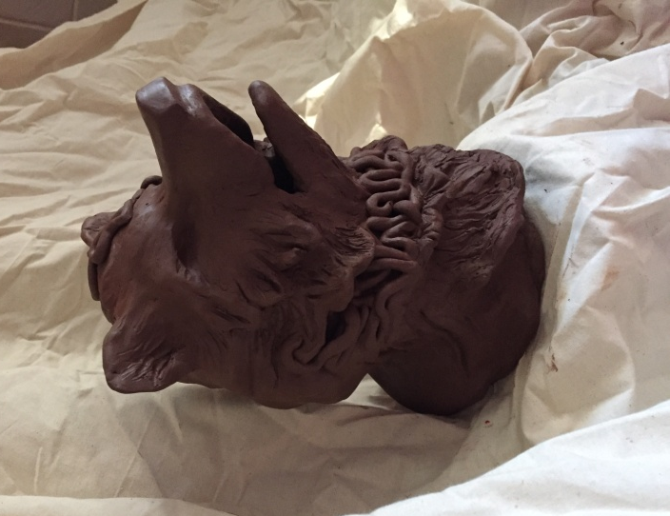

Symbolise the anomalies of the mind in harmful and dark aspects just to serve human whims as a sign to the hunting of animals for the thrill and the sheer evil of the poachers who do it.
I am satisfied with the result but next time I will carve more instead of adding extra clay to the figures to be much leaner.
In addition to the main works, I drew some paintings on A3 and A4 Canson papers which need to be framed later. The aim of these pieces is for them to be suitable for sale purposes with the proceeds as a donation to PETA. Some are from pure imagination and others are inspired by photos alongside those works that I have developed from previous practical studies. To implement these selections, I used different materials and techniques like watercolours, ink, and acrylic and knife technique. I decided to make them with a variety of textures with the aim of satisfying different tastes to encourage sales. I felt I had greater artistic freedom and thus more comfortable in working on these pieces because I felt less bound by restrictions. I liked some paintings, whereas I felt that others needed improvement so as to have a deeper level of maturity.
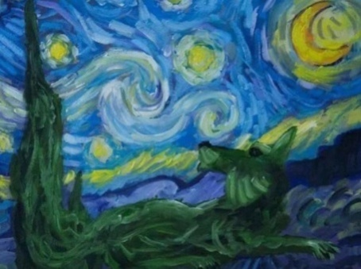
However, in general, I am satisfied with the result and I think adding a frame to these pictures when exhibiting them will provide a level of professionalism and a nice, finished touch.
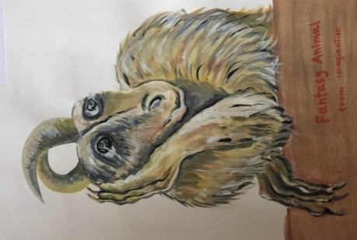

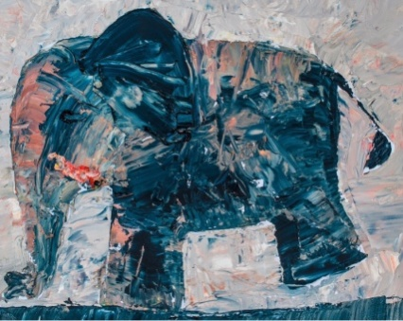
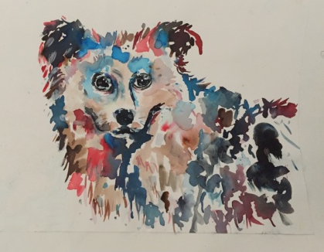

To summarise my outcome, I think I was successful in developing my practical experiments to have the required results. Also, I think I was able to show my capability of self-directing my work through research, analysis, and self-assessment. In addition, I believe that I have achieved my goal for a meaningful connection between the concept of my idea theoretically and practically.
Finally, even though working from home, under many pressures and without the usual guidance, besides it has been very hard and challenging, I still think I managed to work through by driving myself to overcome any obstacles. Hopefully, I have demonstrated my ability to self-direct through my art in this project.

