Final Outcome Inspiration

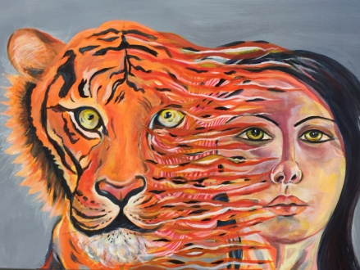
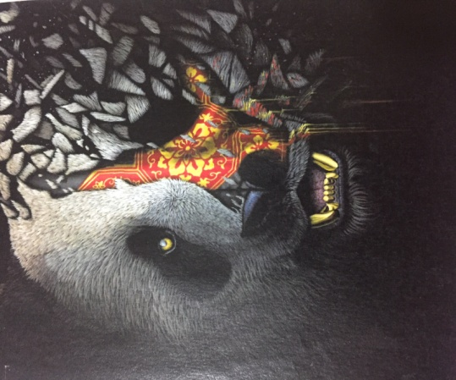
In my painting “Vanishing” I had been inspired by Sonny’s piece ” To The Bone ” which tiptoeing between reality and fantasy. I liked how the animal portrait was rendered in great detail with part of its flesh stripped down to the bone to reveal the colourful patterns. I also liked how he depicted the animal with golden teeth that allude to the reason it is targeted by the poachers.

This piece has been inspired by Pat Devane Burns’s sculpture” Prelude to a Prowl” that represents a wolf howling. I have been impressed by how the artist captured the moment subtly.

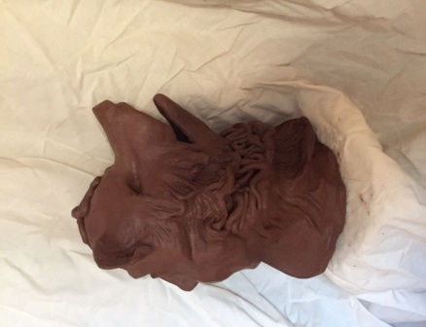

In my painting “The Control “I have been inspired by Americo Hume's painting "toro en Azul".
I liked how the artist expressed the animal’s themes in his artwork. I also admired the audacity of using the sharpest colours side by side, giving his works a feeling of rebellion.
