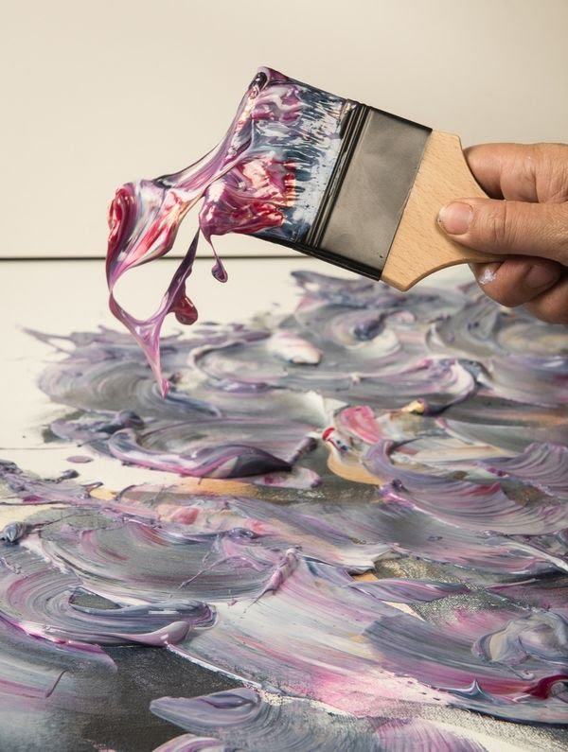**Researching of Materials and Techniques for an Appropriate Final Outcome**

Following my decision in choosing my final ideas (sketches). I had to choose the right materials and techniques to achieve a professional appropriate creative outcome.  I came up with two possible materials that are appropriate to implementations.

I was considering Oil and Acrylic colours. I decided to stick with the Acrylic colours for the following reasons:

1-It needs a few simple tools: Acrylics are not a high-maintenance medium. While we will need many (sometimes expensive) supplies to paint using oil painting (paint, solvents, mediums, brushes, rags, gesso, canvas or board, and a ventilated space), while I need just four simple tools to get started with acrylics: the paint itself, a brush, a cup of water, and a surface (canvas or wooden board) the higher quality of the acrylics are, the more pigment they’ll contain like When we are building a house, we have to build a really good foundation, and then everything follows from there.

For this reason, I usually use Winsor and Newton acrylic paint. For brushes, I don’t need too many, and I always use brushes with synthetic bristles, instead of raw animal hairs. The choice not just due to morality purposes but because the synthetic bristles simply take better to acrylic paints.

While oil paints—which often requires solvents like turpentine, a safe disposal tool for toxic materials, and the time-consuming task of removing paint from brushes––cleaning up with

acrylics will feel like a breeze. If we are using a palette, we can easily scrape off any excess paint, and then run a wet rag over its surface to finish removing the residue. Or, we can let the palette dry and peel the paint off.

2- We can control its consistency and texture: One of the most significant aspects of acrylics is how malleable they are. If we incorporate a medium––an additive that thins or thickens our material––acrylics can take on the qualities of other paints. For example, if we add an acrylic retarder with the paint, it will decelerate the drying time so that it acts more like an oil-based paint. We can also add mediums to make the acrylics crackle, shimmer, or dry even faster.

3. Acrylics allow us to paint anywhere

One of the most costly aspects—for both finance and health—is that oil paints require a ventilated area. Oil-based paints carry many hazardous health concerns, and if there’s no ventilation, solvents like mineral spirits and turpentine fill the air with fumes.

So, if the budget is tight for a ventilated studio space, or if we simply want to paint in in our houses (kitchen or living room, ) like our current situation we have no other choice during the lockdown situation, acrylics are a great option. Since they’re water-based, “there’s not as much in there that gives off-gases, and you don’t have to use solvents with them. While we might rush to scrub oil paints off of our hands in fear of irritation, acrylics are easier on the skin.

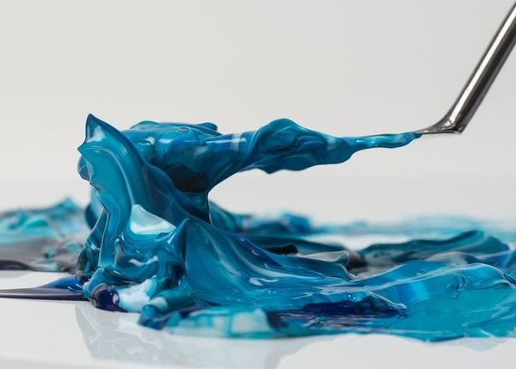

## 4. Acrylics dry fast, so you can layer colours quickly

One of the reasons I was so attracted to acrylic paints was because of how quickly they dry.  We can put down a thick layer of acrylic paint, and in a few hours, it’s dry enough to put down another layer.  While the oils paint takes days to dry.

Another malleable aspect of acrylics is their ability to take on three-dimensional form. “An oil paint, watercolour, or wax-based paint’s purpose is to be stuck to a surface and remain on that surface,” explained Tauchid, “whereas an acrylic can be peeled off of a non-stick surface and used as a soft sculpture material, so it surpasses the realm of paint and goes into the realm of sculpture and collage.”

Although the idea of paint becoming a sculpture may seem far-fetched, there are many artists who specifically use acrylics to build large amounts of sculptural texture on their surfaces. The late Jack Whitten even collaged bits of acrylics onto his canvases, taking into consideration their reflectiveness, transparency, and colour. Whitten, like many other artists, saw in the medium a tried and true benefit: “They’re more versatile than any other paint medium and not just oils,” Tauchid explained.

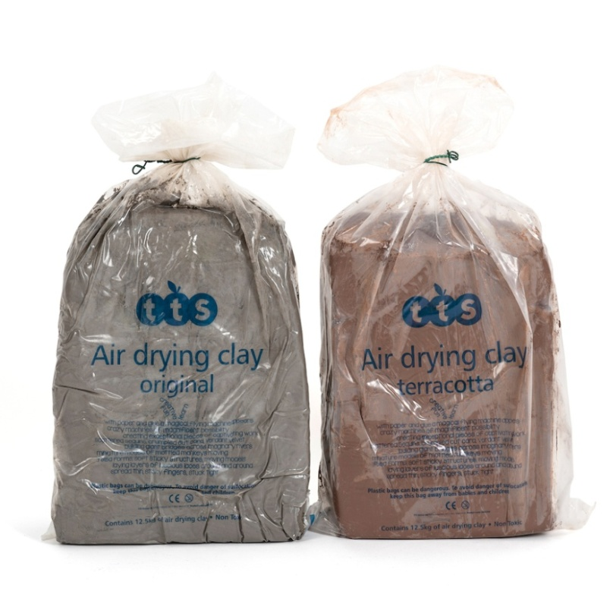

I have also used the Air Dry Clay to implement a piece of sculpture for my final realization.

 Self-hardening clay, also known as air-dried or non-firing clay, is a direct modelling material that cures naturally and does not require mould making and casting to achieve a finished piece. In addition, this modelling clay does not need to be fired in a kiln.

Air-Dry clay has a permanent shape after drying. Most brands of air-dry clay are non-toxic. Air-Dry clay will not pick up every piece of dust like the oven-bake clay.

The Benefits of using the clay in sculpture:

1-The possibility for expression is unlimited because the malleability of clay makes it possible to bend and shape it into any shape imaginable.

2- It needs a few simple tools

3-helps develop hand-eye coordination and fine motor skills and helps us focus.

4-helps with creative problem-solving.

5-manipulating clay is therapeutic.

